Assignment-4

**Vanshika Bansal: 1710110374**

**Akarsh Kala: 1710110033**

Posting date: 14th Nov 2019

Submission Date: 27th Nov by 3pm;

Do in group of **2 students**

Implement FIS (Fuzzy Inference System) using METLAB fuzzy logic toolbox and evaluate the performance of a student. The goal is to find the overall performance of the student. The evaluation criteria are based on the following three input parameters. The output of the system is the performance score of a given student in range [0, 10].

**Inputs:**

* Academics: Performance in academics are measured by CGPA (scale 0-10)
* Sports: Total number of games won or participated (scale 0-10)
* Co-curricular activities: the number of certificates (participation and winning certificate in the range of 0 to 10).

Define the following and make a document containing all details in text file.

* Define linguistic variables - Academics, sports and co-curricular (3 input) and performance (1 output) and the corresponding fuzzy membership functions

ACADEMICS: Define and fuzzy membership function

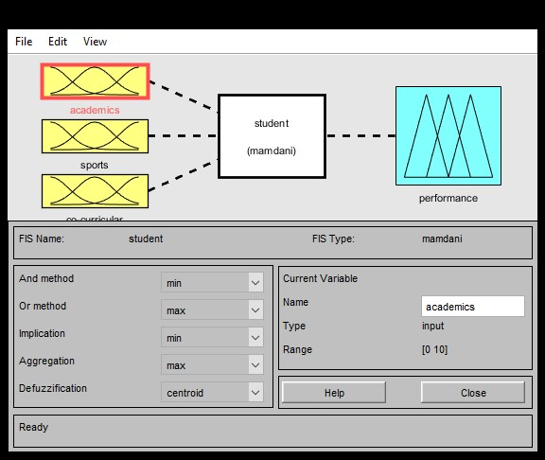

Academics is distributed in three ranges ie, poor, average and good. If cgpa is less than 4, it comes in poor category. The average ranges between 3 and 8 where the plot is stable for 5 to 7. Finally, 8 above is considered to be in good category.

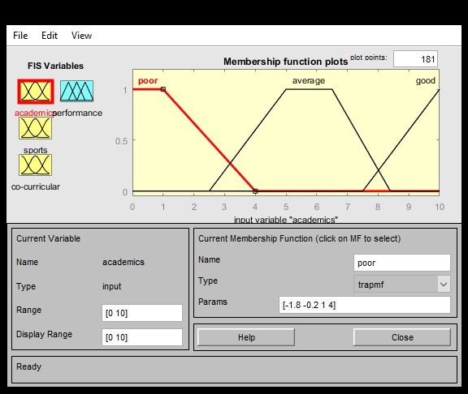

SPORTS: Define and fuzzy membership function

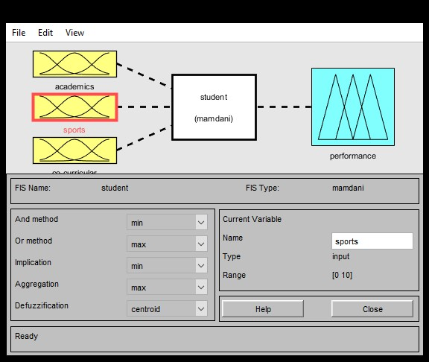

Sports is distributed in three ranges ie, poor, average and good. If number of games won is less than 2, it comes in poor category. The average ranges between 1 and 5. Finally, 5 above is considered to be in good category. Here, we have started the good range early because even these values are considered good in the field of sports.

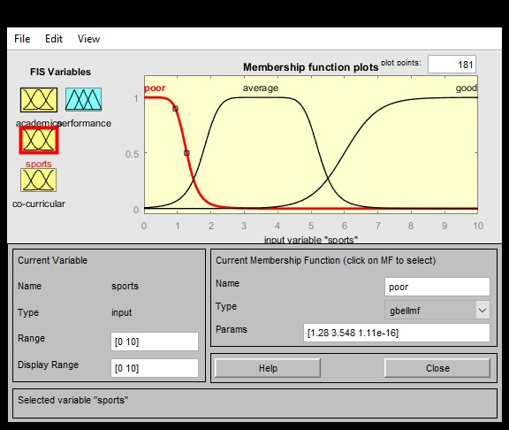

CO-CURRICULUM: Define and fuzzy membership function

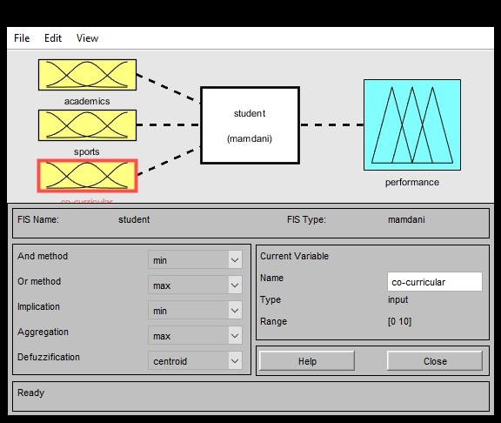

Co-curriculum is distributed in three ranges ie, poor, average and good. If number of certificates is less than 2, it comes in poor category. The average ranges between 1 and 6. The plot is stable for most of this range Finally, 4 above is considered to be in good category. The performance keeps on increasing after that.

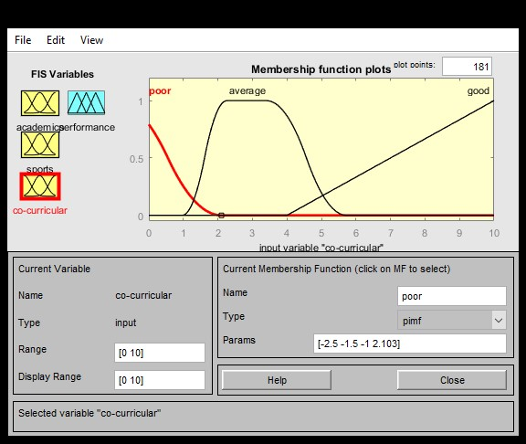

PERFORMANCE: Define and fuzzy membership function

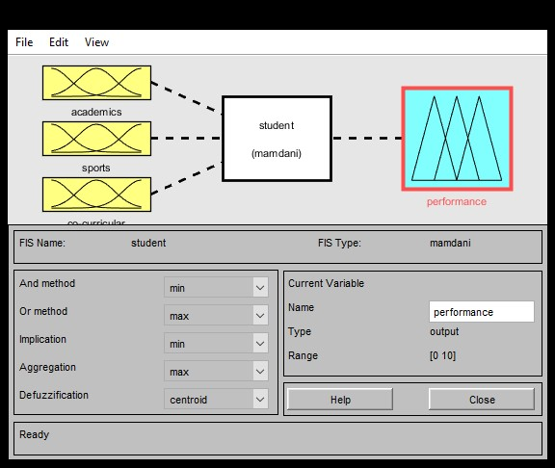

Performance is distributed in three ranges ie, poor, average and good. If the cumulative performance is less than 3, it comes in poor category. The average ranges between 2 and 8 with the peak in the mid value. Finally, 8 above is considered to be in good category.

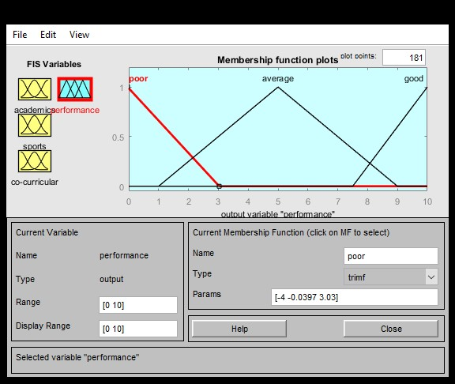

* Define Fuzzy rule base that seems to be suitable for the given system.

Based on the nature of FIS input and output variables used and general logical sense, we have defined a rule base that suits best for our student performance model.

RULE BASE:

* 1. If (academics is good) then (performance is good) (1)
  2. If (academics is average) and (sports is good) and (co-curricular is good) then (performance is good) (1)
  3. If (academics is average) and (sports is good) and (co-curricular is not good) then (performance is good) (1)
  4. If (academics is average) and (sports is not good) and (co-curricular is good) then (performance is good) (1)
  5. If (academics is average) and (sports is average) and (co-curricular is average) then (performance is average) (1)
  6. If (academics is average) and (sports is poor) and (co-curricular is poor) then (performance is poor) (1)
  7. If (academics is average) and (sports is average) and (co-curricular is poor) then (performance is average) (1)
  8. If (academics is average) and (sports is poor) and (co-curricular is average) then (performance is average) (1)
  9. If (academics is poor) and (sports is good) and (co-curricular is good) then (performance is average) (1)
  10. If (academics is poor) and (sports is not good) and (co-curricular is not good) then (performance is poor) (1)

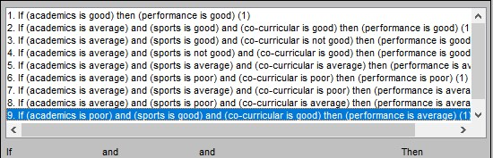

* Develop FIS to compute performance of the student

TEST CASES:

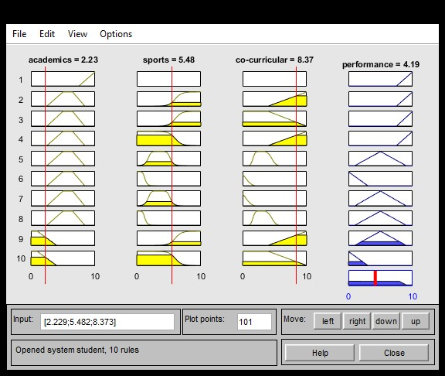

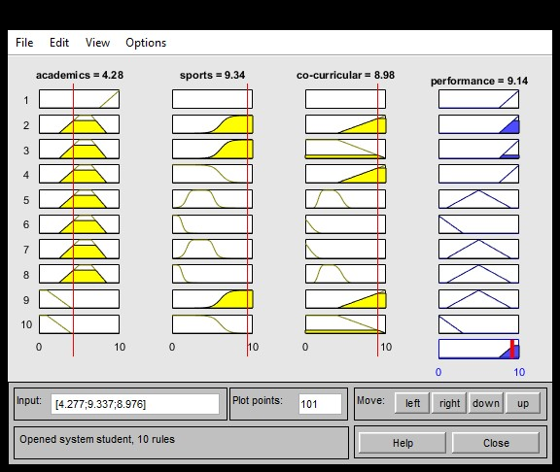

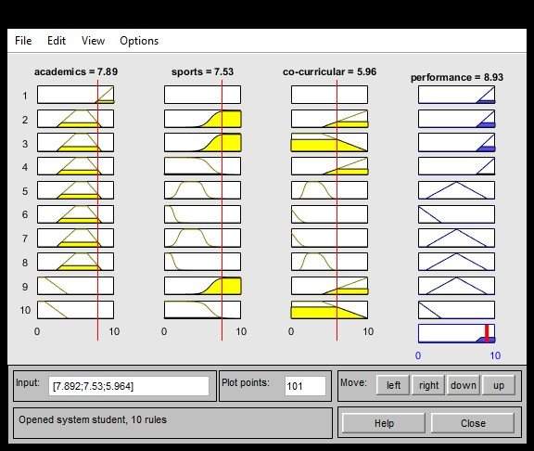

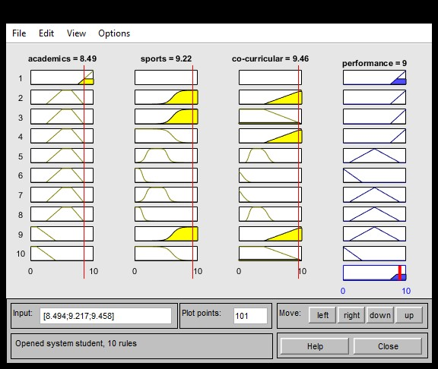

The inputs are given to the system and based on the plots and rules, first fuzzification and after that defuzzification takes place. We have used centroid defuzzification logic, since we have 3 inputs- the centroid is the optimal point.